Assignment 1: Report

Venkata Bapanapalli

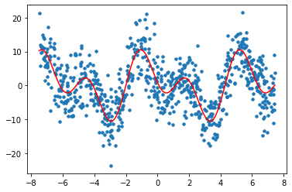

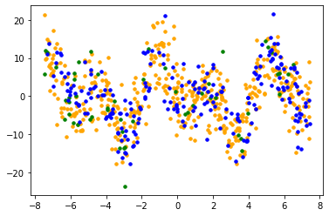

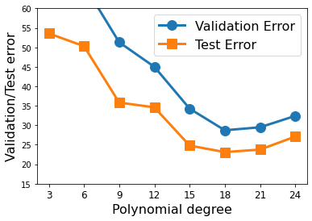

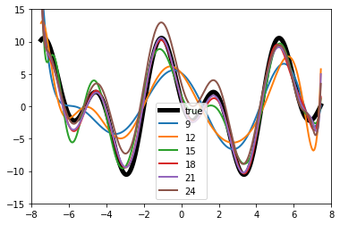

Part 1 Discussion:

From the above graph a value of 15 seems to be the best value for d. A value higher than this suffers from overfitting and the values below seem to underfit. Hence, I believe a value of 15 seems to generalize best.

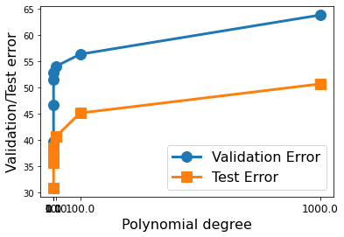

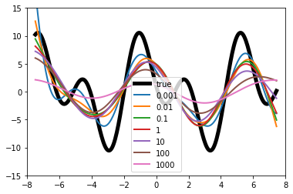

Part 2c:

From the graph it can be said that the lambda value of 0.001 provides the best generalization. As the values of lambda increase the functions for the respective lambda values over generalize.

Part 2 Discussion:

From the above graph we can reasonably say that as the value of lambda increases the linearity of the model decreases. As the values go up to 1000 the function generalizes and becomes unpredictable.